Assignment 6: Logistic

CIS 435

Section 56

Summer Quarter

School of Continuing Studies

Northwestern University

Daniel Prusinski

Business Intelligence Data Analyst

Target Corporation

Minneapolis, MN

In Compliance with Master of Science Predictive Analytics

Screen Shots and Output for Initial Comparative Analysis:

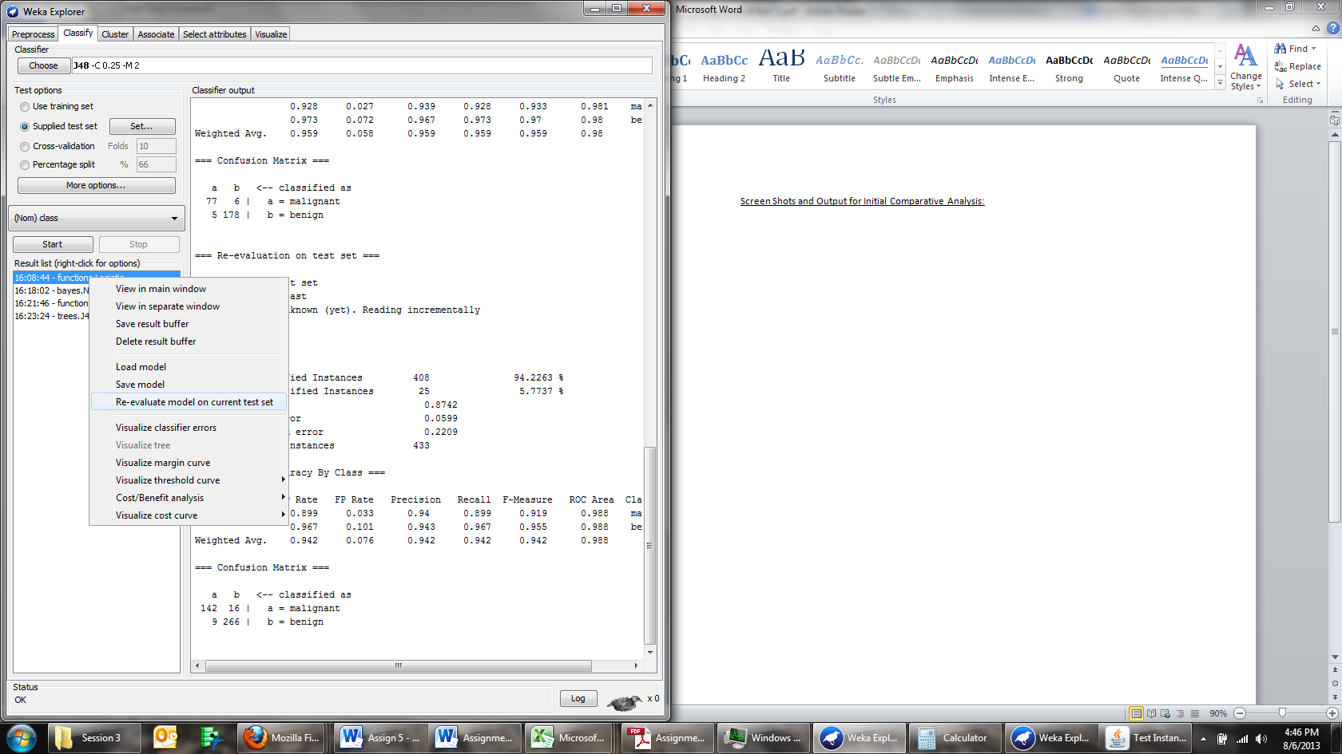

This is the option I selected for each algorithm after I loaded the testing data and changed the setting to Supplied test set.

Output:

This is the output generated from each algorithm, the training data is the first output, and the testing data is the second output.

=== Run information ===

Scheme:weka.classifiers.bayes.NaiveBayes

Relation: Breast

Instances: 266

Attributes: 10

clump

ucellsize

ucellshape

magadhesion

sepics

bnuclei

bchromatin

normnucl

mitoses

class

Test mode:10-fold cross-validation

=== Classifier model (full training set) ===

Naive Bayes Classifier

Class

Attribute malignant benign

(0.31) (0.69)

===================================

clump

mean 7.3735 2.847

std. dev. 2.2746 1.682

weight sum 83 183

precision 1 1

ucellsize

mean 6.3133 1.3552

std. dev. 2.5551 0.9915

weight sum 83 183

precision 1 1

ucellshape

mean 6.3855 1.4918

std. dev. 2.3431 1.1302

weight sum 83 183

precision 1 1

magadhesion

mean 5.5422 1.306

std. dev. 3.152 0.7991

weight sum 83 183

precision 1 1

sepics

mean 5.2861 2.3914

std. dev. 2.3671 0.9631

weight sum 83 183

precision 1.125 1.125

bnuclei

mean 7.631 1.4754

std. dev. 3.0898 1.162

weight sum 83 183

precision 1.125 1.125

bchromatin

mean 5.8193 1.9891

std. dev. 2.066 0.9408

weight sum 83 183

precision 1 1

normnucl

mean 5.9036 1.2951

std. dev. 3.3496 0.9469

weight sum 83 183

precision 1 1

mitoses

mean 2.6747 1.5246

std. dev. 2.4203 0.25

weight sum 83 183

precision 1.5 1.5

Time taken to build model: 0.02 seconds

=== Stratified cross-validation ===

=== Summary ===

Correctly Classified Instances 256 96.2406 %

Incorrectly Classified Instances 10 3.7594 %

Kappa statistic 0.9147

Mean absolute error 0.0375

Root mean squared error 0.1923

Relative absolute error 8.7194 %

Root relative squared error 41.4934 %

Total Number of Instances 266

=== Detailed Accuracy By Class ===

TP Rate FP Rate Precision Recall F-Measure ROC Area Class

0.988 0.049 0.901 0.988 0.943 0.985 malignant

0.951 0.012 0.994 0.951 0.972 0.989 benign

Weighted Avg. 0.962 0.024 0.965 0.962 0.963 0.987

=== Confusion Matrix ===

a b <-- classified as

82 1 | a = malignant

9 174 | b = benign

=== Re-evaluation on test set ===

User supplied test set

Relation: Breast

Instances: unknown (yet). Reading incrementally

Attributes: 10

=== Summary ===

Correctly Classified Instances 414 95.612 %

Incorrectly Classified Instances 19 4.388 %

Kappa statistic 0.9065

Mean absolute error 0.0437

Root mean squared error 0.2043

Total Number of Instances 433

=== Detailed Accuracy By Class ===

TP Rate FP Rate Precision Recall F-Measure ROC Area Class

0.968 0.051 0.916 0.968 0.942 0.982 malignant

0.949 0.032 0.981 0.949 0.965 0.987 benign

Weighted Avg. 0.956 0.039 0.957 0.956 0.956 0.985

=== Confusion Matrix ===

a b <-- classified as

153 5 | a = malignant

14 261 | b = benign

=== Run information ===

Scheme:weka.classifiers.functions.Logistic -R 1.0E-8 -M -1

Relation: Breast

Instances: 266

Attributes: 10

clump

ucellsize

ucellshape

magadhesion

sepics

bnuclei

bchromatin

normnucl

mitoses

class

Test mode:10-fold cross-validation

=== Classifier model (full training set) ===

Logistic Regression with ridge parameter of 1.0E-8

Coefficients...

Class

Variable malignant

========================

clump 0.7195

ucellsize 0.1651

ucellshape 0.0934

magadhesion 0.7147

sepics 0.501

bnuclei 0.2839

bchromatin 1.9842

normnucl 0.4885

mitoses 3.2358

Intercept -24.0634

Odds Ratios...

Class

Variable malignant

========================

clump 2.0533

ucellsize 1.1795

ucellshape 1.0979

magadhesion 2.0435

sepics 1.6503

bnuclei 1.3283

bchromatin 7.2732

normnucl 1.6299

mitoses 25.4269

Time taken to build model: 0.16 seconds

=== Stratified cross-validation ===

=== Summary ===

Correctly Classified Instances 255 95.8647 %

Incorrectly Classified Instances 11 4.1353 %

Kappa statistic 0.9034

Mean absolute error 0.0409

Root mean squared error 0.1842

Relative absolute error 9.5082 %

Root relative squared error 39.751 %

Total Number of Instances 266

=== Detailed Accuracy By Class ===

TP Rate FP Rate Precision Recall F-Measure ROC Area Class

0.928 0.027 0.939 0.928 0.933 0.981 malignant

0.973 0.072 0.967 0.973 0.97 0.98 benign

Weighted Avg. 0.959 0.058 0.959 0.959 0.959 0.98

=== Confusion Matrix ===

a b <-- classified as

77 6 | a = malignant

5 178 | b = benign

=== Re-evaluation on test set ===

User supplied test set

Relation: Breast

Instances: unknown (yet). Reading incrementally

Attributes: 10

=== Summary ===

Correctly Classified Instances 408 94.2263 %

Incorrectly Classified Instances 25 5.7737 %

Kappa statistic 0.8742

Mean absolute error 0.0599

Root mean squared error 0.2209

Total Number of Instances 433

=== Detailed Accuracy By Class ===

TP Rate FP Rate Precision Recall F-Measure ROC Area Class

0.899 0.033 0.94 0.899 0.919 0.988 malignant

0.967 0.101 0.943 0.967 0.955 0.988 benign

Weighted Avg. 0.942 0.076 0.942 0.942 0.942 0.988

=== Confusion Matrix ===

a b <-- classified as

142 16 | a = malignant

9 266 | b = benign

=== Run information ===

Scheme:weka.classifiers.functions.MultilayerPerceptron -L 0.3 -M 0.2 -N 500 -V 0 -S 0 -E 20 -H a

Relation: Breast

Instances: 266

Attributes: 10

clump

ucellsize

ucellshape

magadhesion

sepics

bnuclei

bchromatin

normnucl

mitoses

class

Test mode:10-fold cross-validation

=== Classifier model (full training set) ===

Sigmoid Node 0

Inputs Weights

Threshold 7.055155276714432

Node 2 -4.337301863948531

Node 3 -3.0161173598673963

Node 4 -0.7982220474723172

Node 5 -6.085042284529997

Node 6 -4.30929039109078

Sigmoid Node 1

Inputs Weights

Threshold -7.051769094486156

Node 2 4.367489741221618

Node 3 3.0135818462756987

Node 4 0.7709079177064214

Node 5 6.084952216490562

Node 6 4.289309962388457

Sigmoid Node 2

Inputs Weights

Threshold -7.060343625080421

Attrib clump -1.3321489951781704

Attrib ucellsize -2.221803038928232

Attrib ucellshape 0.46054977587612655

Attrib magadhesion 0.11109734331744317

Attrib sepics 0.4509101345007964

Attrib bnuclei -0.36464427850075487

Attrib bchromatin -3.8115362484968527

Attrib normnucl -1.113122799678163

Attrib mitoses -4.471968592884483

Sigmoid Node 3

Inputs Weights

Threshold -3.167951207840781

Attrib clump -1.546611979564754

Attrib ucellsize -0.12046672746964626

Attrib ucellshape 1.6813556814481532

Attrib magadhesion -1.3477474996236525

Attrib sepics -0.41418045472018844

Attrib bnuclei 2.9955120549916456

Attrib bchromatin -1.6062368854546754

Attrib normnucl -0.7812300214838922

Attrib mitoses -3.330536526233263

Sigmoid Node 4

Inputs Weights

Threshold -1.832069827023158

Attrib clump -0.5221776395664868

Attrib ucellsize -0.2084443513826472

Attrib ucellshape -0.08818764384123014

Attrib magadhesion 0.06125933748622355

Attrib sepics 0.4618374671709951

Attrib bnuclei 0.27158058176459027

Attrib bchromatin -1.0287805087743764

Attrib normnucl -0.6184457941437396

Attrib mitoses -0.8083815371372266

Sigmoid Node 5

Inputs Weights

Threshold -9.452450717449164

Attrib clump -3.036789601429978

Attrib ucellsize -2.2118472816700887

Attrib ucellshape 3.3404836112210616

Attrib magadhesion -1.7817622651463667

Attrib sepics -1.8821814137866624

Attrib bnuclei -2.627772667188493

Attrib bchromatin -2.589261423029245

Attrib normnucl -0.02366238692326025

Attrib mitoses -5.3786470649415055

Sigmoid Node 6

Inputs Weights

Threshold -7.586627165043234

Attrib clump -1.9088837465055224

Attrib ucellsize -1.9059819387948327

Attrib ucellshape 1.86221468566607

Attrib magadhesion -1.089390921803328

Attrib sepics -1.1523999000110714

Attrib bnuclei -1.6643222679285519

Attrib bchromatin -2.432257581663086

Attrib normnucl -0.13513124138206933

Attrib mitoses -4.0148964002917005

Class malignant

Input

Node 0

Class benign

Input

Node 1

Time taken to build model: 1.52 seconds

=== Stratified cross-validation ===

=== Summary ===

Correctly Classified Instances 256 96.2406 %

Incorrectly Classified Instances 10 3.7594 %

Kappa statistic 0.9119

Mean absolute error 0.0416

Root mean squared error 0.1828

Relative absolute error 9.6708 %

Root relative squared error 39.4424 %

Total Number of Instances 266

=== Detailed Accuracy By Class ===

TP Rate FP Rate Precision Recall F-Measure ROC Area Class

0.928 0.022 0.951 0.928 0.939 0.991 malignant

0.978 0.072 0.968 0.978 0.973 0.991 benign

Weighted Avg. 0.962 0.057 0.962 0.962 0.962 0.991

=== Confusion Matrix ===

a b <-- classified as

77 6 | a = malignant

4 179 | b = benign

=== Re-evaluation on test set ===

User supplied test set

Relation: Breast

Instances: unknown (yet). Reading incrementally

Attributes: 10

=== Summary ===

Correctly Classified Instances 408 94.2263 %

Incorrectly Classified Instances 25 5.7737 %

Kappa statistic 0.8749

Mean absolute error 0.0617

Root mean squared error 0.217

Total Number of Instances 433

=== Detailed Accuracy By Class ===

TP Rate FP Rate Precision Recall F-Measure ROC Area Class

0.911 0.04 0.929 0.911 0.92 0.98 malignant

0.96 0.089 0.95 0.96 0.955 0.98 benign

Weighted Avg. 0.942 0.071 0.942 0.942 0.942 0.98

=== Confusion Matrix ===

a b <-- classified as

144 14 | a = malignant

11 264 | b = benign

=== Run information ===

Scheme:weka.classifiers.trees.J48 -C 0.25 -M 2

Relation: Breast

Instances: 266

Attributes: 10

clump

ucellsize

ucellshape

magadhesion

sepics

bnuclei

bchromatin

normnucl

mitoses

class

Test mode:10-fold cross-validation

=== Classifier model (full training set) ===

J48 pruned tree

------------------

bchromatin <= 3

| clump <= 6

| | ucellsize <= 2: benign (165.0)

| | ucellsize > 2

| | | ucellsize <= 5: benign (12.0/1.0)

| | | ucellsize > 5: malignant (4.0/1.0)

| clump > 6: malignant (11.0/1.0)

bchromatin > 3

| bnuclei <= 8

| | clump <= 3: benign (2.0)

| | clump > 3

| | | bchromatin <= 4

| | | | mitoses <= 1: benign (4.0/1.0)

| | | | mitoses > 1: malignant (4.0)

| | | bchromatin > 4: malignant (23.0)

| bnuclei > 8: malignant (41.0)

Number of Leaves : 9

Size of the tree : 17

Time taken to build model: 0.06 seconds

=== Stratified cross-validation ===

=== Summary ===

Correctly Classified Instances 249 93.609 %

Incorrectly Classified Instances 17 6.391 %

Kappa statistic 0.8516

Mean absolute error 0.0762

Root mean squared error 0.2489

Relative absolute error 17.7284 %

Root relative squared error 53.7172 %

Total Number of Instances 266

=== Detailed Accuracy By Class ===

TP Rate FP Rate Precision Recall F-Measure ROC Area Class

0.904 0.049 0.893 0.904 0.898 0.93 malignant

0.951 0.096 0.956 0.951 0.953 0.93 benign

Weighted Avg. 0.936 0.082 0.936 0.936 0.936 0.93

=== Confusion Matrix ===

a b <-- classified as

75 8 | a = malignant

9 174 | b = benign

=== Re-evaluation on test set ===

User supplied test set

Relation: Breast

Instances: unknown (yet). Reading incrementally

Attributes: 10

=== Summary ===

Correctly Classified Instances 406 93.7644 %

Incorrectly Classified Instances 27 6.2356 %

Kappa statistic 0.8634

Mean absolute error 0.0665

Root mean squared error 0.2326

Total Number of Instances 433

=== Detailed Accuracy By Class ===

TP Rate FP Rate Precision Recall F-Measure ROC Area Class

0.88 0.029 0.946 0.88 0.911 0.962 malignant

0.971 0.12 0.934 0.971 0.952 0.962 benign

Weighted Avg. 0.938 0.087 0.938 0.938 0.937 0.962

=== Confusion Matrix ===

a b <-- classified as

139 19 | a = malignant

8 267 | b = benign

**Initial Analysis**:

The data set being studied has 10 attributes and 433 instances. Given that this dataset is titled Breast, I am assuming it relates to the diagnoses of breast cancer. Based on the class attribute, I am also assuming that 158 cases are not cancer (blue) and 275 cases are cancer (red). Shown below is the graphical distribution of the 10 attributes.

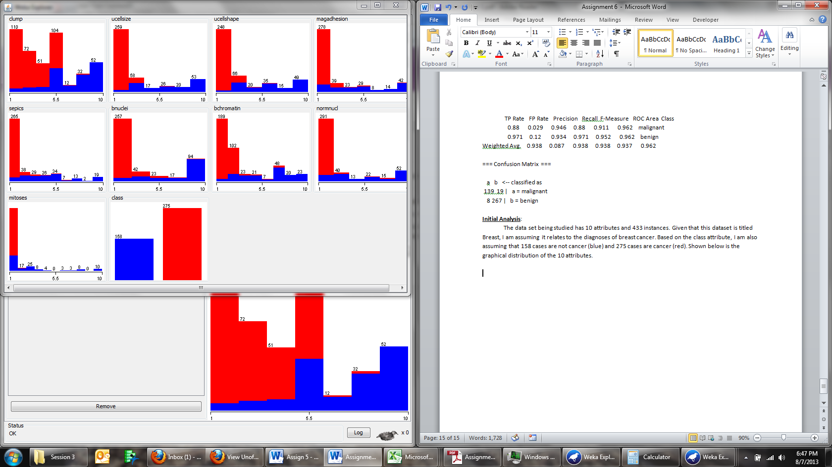

Notice how the attribute Class perfectly classifies the binary response of the diagnoses. The variables initially appear to be continuous.

Observations:

In this exploratory data analysis (EDA) fit and correctly classified instances are major key performance indicators (KPIs). In addition to these KPIs, false positive rate is another major KPI given that the data is diagnostic in nature. Thus far in this class, we have yet to test our models, which changes with this EDA. The last KPI I will be looking at is the change from the training data to the testing data. The four KPI’s listed above will prove to be the delineating factors when assessing the best model.

Naïve Bayes

The term Malignant in medical diagnostics means harmful, where benign is interpreted as non-harmful. Out of the four diagnosis shown below, I care most about B,A which is 1 in the training cross-tab below. This number represents the number of patients that are diagnosed as a tumor being benign but in fact

they are falsely benign meaning they are actually malignant. As one can infer, this false diagnostic allows the cancer to grow and decreases the probability of survival for a patient greatly. The rate of False Negative (FN) on the training data is .003% and .01% on the testing data. This is a 233% increase, which is quite high, but overall still amounts to 1% of all patients. Moving forward I would want to test this on a larger data set.

Testing

a b <-- classified as

153 5 | a = malignant

14 261 | b = benign

Training

a b <-- classified as

82 1 | a = malignant

9 174 | b = benign

The correctly classified instances for training data were 96.2406 and 95.612% for the testing data. Overall this is a .6286% change. In addition, the root mean square error was .1923 for training, and .2043 for testing which is a .06% change. Overall, this is a strong model and I am the most concerned with the false negatives as a KPI moving forward.

Logistic

Logistic Regression is used as a non-linear transformer in the MLP process. The goal of using logistic regression is to linearly analyze data that initially is not linear. This process is done through maximum likelihood estimation.

Training:

Correctly Classified Instances 255 95.8647 %

a b <-- classified as

77 6 | a = malignant

5 178 | b = benign

Root mean squared error 0.1842

=== Re-evaluation on test set ===

Correctly Classified Instances 408 94.2263 %

a b <-- classified as

142 16 | a = malignant

9 266 | b = benign

Root mean squared error 0.2209

The rate of False Negative (FN) on the training data is 6/266 = .022 and 16/433= .037 on the testing data. The calculation for change is (.037-.022)/.022 = .681 increase, which is quite high, but overall still amounts to 16/433=.03 or 3% all patients. Comparing this to Naïve Bayes, Naïve Bayes is clearly a better model for this specific KPI. Moving forward I would want to test this on a larger data set.

The correctly classified instances for training data were 95.8647 and 94.2263% for the testing data. Overall this is a - 1.6384% change in accuracy. Ideally, one does not want to see accuracy deteriorate. In addition, the root mean square error was .1842 for training, and .2209 for testing which is a (.2209-.1842)/.1842 = 19% increase in errors from the two different models. Overall, I am not impressed with this model compared to the Naïve Bayes. Initially, the root mean square error was lower for Logistic than Naïve Bayes but on the testing data it is larger, which leads me to believe that over fitting might be a small issue.

Multilayer Perceptron

Shown below is an example of a Neural Network that has one hidden layer. Each node had multiple iterations, which is seen through the increase in weight.

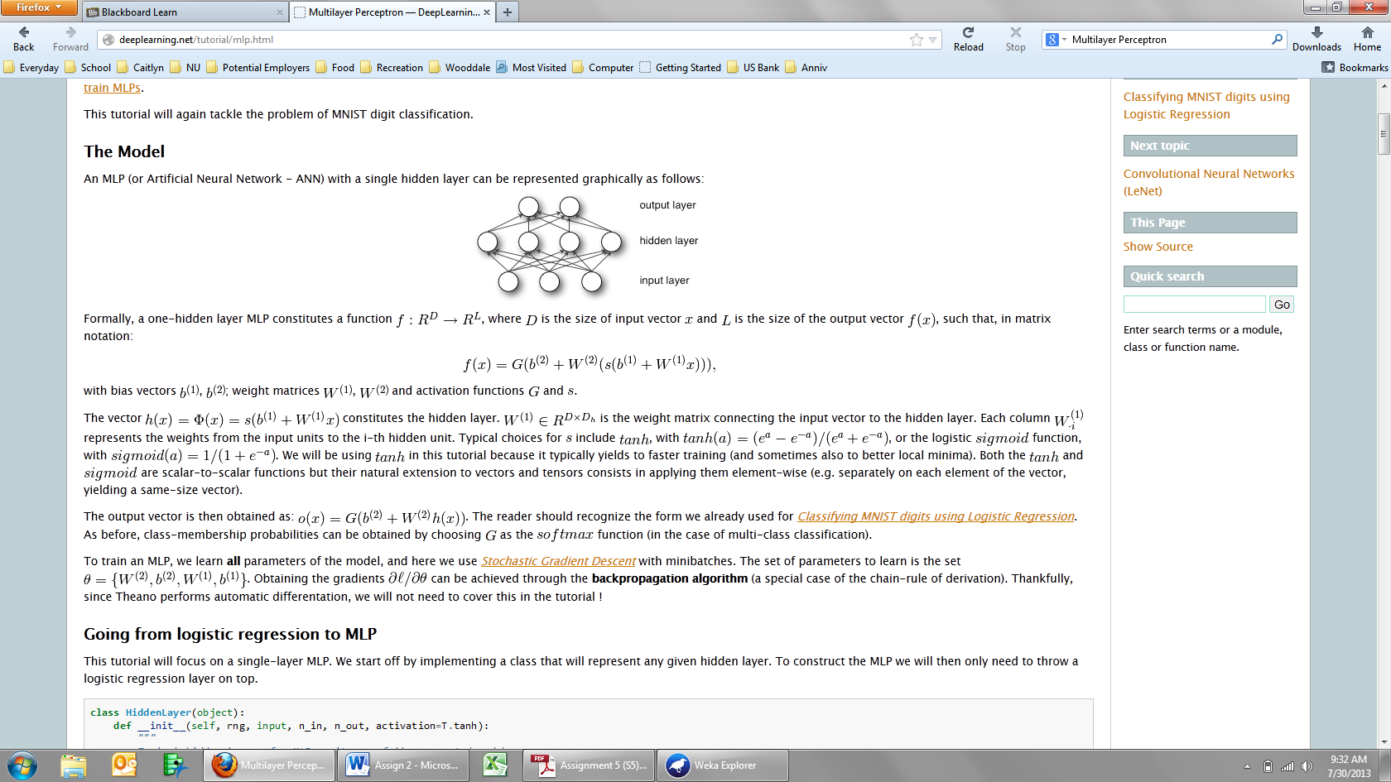

=== Classifier model (full training set) ===

Correctly Classified Instances 256 96.2406 %

Root mean squared error 0.1828

a b <-- classified as

77 6 | a = malignant

4 179 | b = benign

=== Re-evaluation on test set ===

Correctly Classified Instances 408 94.2263 %

Root mean squared error 0.217

a b <-- classified as

144 14 | a = malignant

11 264 | b = benign

The rate of False Negative (FN) on the training data is 6/266 = .022 and 14/433= .032 on the testing data. The calculation for change is (.032-.022)/.022 = .454 increase, which is quite high, but overall still amounts to 14/433=.03 or 3% of all patients. Comparing this to Naïve Bayes, Naïve Bayes is clearly a better model for this specific KPI. Moving forward I would want to test this on a larger data set.

The correctly classified instances for training data were 96.2406 and 94.2263% for the testing data. Overall this is a - 2.143% change in accuracy. Ideally, one does not want to see accuracy deteriorate. In addition, the root mean square error was .1828 for training, and .217 for testing which is a (.217-.1828)/.1828 = 18% increase in errors from the two different models. Overall, I am not impressed with this model compared to the Naïve Bayes. Initially, the root mean square error was lower for Perceptron than Naïve Bayes but on the testing data it is larger, which leads me to believe that over fitting might be a small issue, if it possible for a neural network. I rank this above logistic based on the fact that the root mean square error is smaller, and the change for false negatives is lower than logistic. This ranking is based on the best desired outcome for the patients being tested.

My current rank is:

* Naïve Bayes
* Multilayer Perceptron
* Logistic

Decision Tree J48

J48 is a top-down approach that separates the example data into subsets (decision tree) and new observations are scored through this tree. The decision tree demonstrataes the top down approach from J48.

=== Classifier model (full training set) ===

Number of Leaves : 9

Size of the tree : 17

Correctly Classified Instances 249 93.609 %

Root mean squared error 0.2489

a b <-- classified as

75 8 | a = malignant

9 174 | b = benign

=== Re-evaluation on test set ===

Correctly Classified Instances 406 93.7644 %

Root mean squared error 0.2326

a b <-- classified as

139 19 | a = malignant

8 267 | b = benign

The rate of False Negative (FN) on the training data is 8/266 = .03 and 19/433= .043 on the testing data. The calculation for change is (.043-.03)/.03 = .433 increase, which is quite high, but overall still amounts to 14/433=.03 or 3% of all patients. Comparing this to Naïve Bayes, Naïve Bayes is clearly a better model for this specific KPI. Moving forward I would want to test this on a larger data set.

The correctly classified instances for training data were 93.609 and 93.7644% for the testing data. Overall this is a .1154% increase in accuracy. Ideally, one does not want to see accuracy deteriorate, which speaks highly for this model. In addition, the root mean square error was .2489 for training, and .2326 for testing which is a (.2326-.2489)/.2489 = .0163% decrease in errors from the two different models. Overall, I am very impressed with this model compared to the Naïve Bayes. Initially, the root mean square error was high but dropped slightly, which shows that it fits the data well. I rank this directly below Naïve Bayes based on the fact that the false negatives increased the most and this model has the highest amount of false negatives. This ranking is based on the best desired outcome for the patients being tested.

Conclusion:

Of all four models, I would rank them as shown below:

1. Naïve Bayes
2. Decision Tree
3. Multilayer Perceptron
4. Logistic

My ranking culminated from analyzing 4 metrics that I labeled KPIs. The false negative ratio was my most valuable KPI because this data is based on cancer diagnostics, of which a false negative can kill a person. Across the KPI’s Naïve Bayes did the best, with the exception of the accuracy between testing and training data – which Decision tree had the best metric. Multilayer Perceptron and Logistic were the two newer algorithms that have been learned. I was surprised Multilayer Perceptron did not perform better, based on the how intense the logic is behind the algorithm. While I appreciate logistic regression, this was not the best situation or data set for logistic regression. In my opinion, logistic regression really adds value in advertising and marketing datasets. Overall, it was exciting to view this data through the different models with the understanding of the medical consequences.